**NAME: SNEHA TIWARI**

**ROLL NO.: 11500119052**

## ASSIGNMENT 3: Connection oriented TCP socket programming (Two Way Communication)

## Client Side: myChatClient.java

import java.io.IOException;

import java.io.PrintStream;

import java.net.Socket;

import java.net.UnknownHostException;

import java.util.Scanner;

public class myChatClient {

public static void main(String arg[]) throws UnknownHostException,IOException

{

    String number,temp;

    Scanner sc = new Scanner(System.in);

    Socket s=new Socket("127.0.0.1",1408);

    Scanner sc1=new Scanner(s.getInputStream());

    System.out.println("Send any message: ");

    number=sc.nextLine();

    PrintStream p=new PrintStream(s.getOutputStream());

    p.println(number);

    temp=sc1.nextLine();

    System.out.println("Message sent by Server: "+temp);

    s.close();

    sc.close();

  }

}

**Output:**

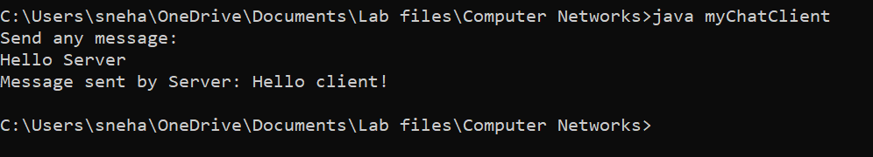

**Server Side: myChatServer.java**

import java.io.IOException;

import java.io.PrintStream;

import java.net.ServerSocket;

import java.net.Socket;

import java.util.Scanner;

public class myChatServer {

    public static void main(String[] args) throws IOException {

        String str;

        ServerSocket s1=new ServerSocket(1408);

        Socket ss=s1.accept();

        Scanner sc=new Scanner(ss.getInputStream());

        str=sc.nextLine();

        PrintStream p=new PrintStream(ss.getOutputStream());

        p.println("Hello client!");

        System.out.println("Message send by client: "+str);

        if(!ss.isClosed())

        {

        s1.close();

        System.out.println("Server closed.");

        }

    }

}

**Output:**



